**Phase 3 Practice Project: Creating Well-Structured .Output for API Clients Using Postman to Get Weather Report.**

**Write Up:**

**Description**

You are asked to create a well-structured output for their API client using Postman, which will hit that URL and get a detailed report on the weather in a quicker way.

Background of the problem statement:

To get the weather report in a well-structured output, we need to have a set of APIs of the weather application and automatable tool like Postman.

**You must use the following:**

Postman

Endpoint URL(<https://samples.openweathermap.org/data/2.5/weather?q=London,uk&appid=b6907d289e10d714a6e88b30761fae22>)

**The following requirements should be met:**

●        A few of the source codes should be tracked on GitHub repositories. You need to document the tracked files that are ignored during the final push to the GitHub repository.

●        The submission of your GitHub repository link is mandatory. In order to track your task, you need to share the link of the repository in the document.

●        The step-by-step process involved in completing this task should be documented.

**Source code: for practice project**

First go to collection area add blank collection 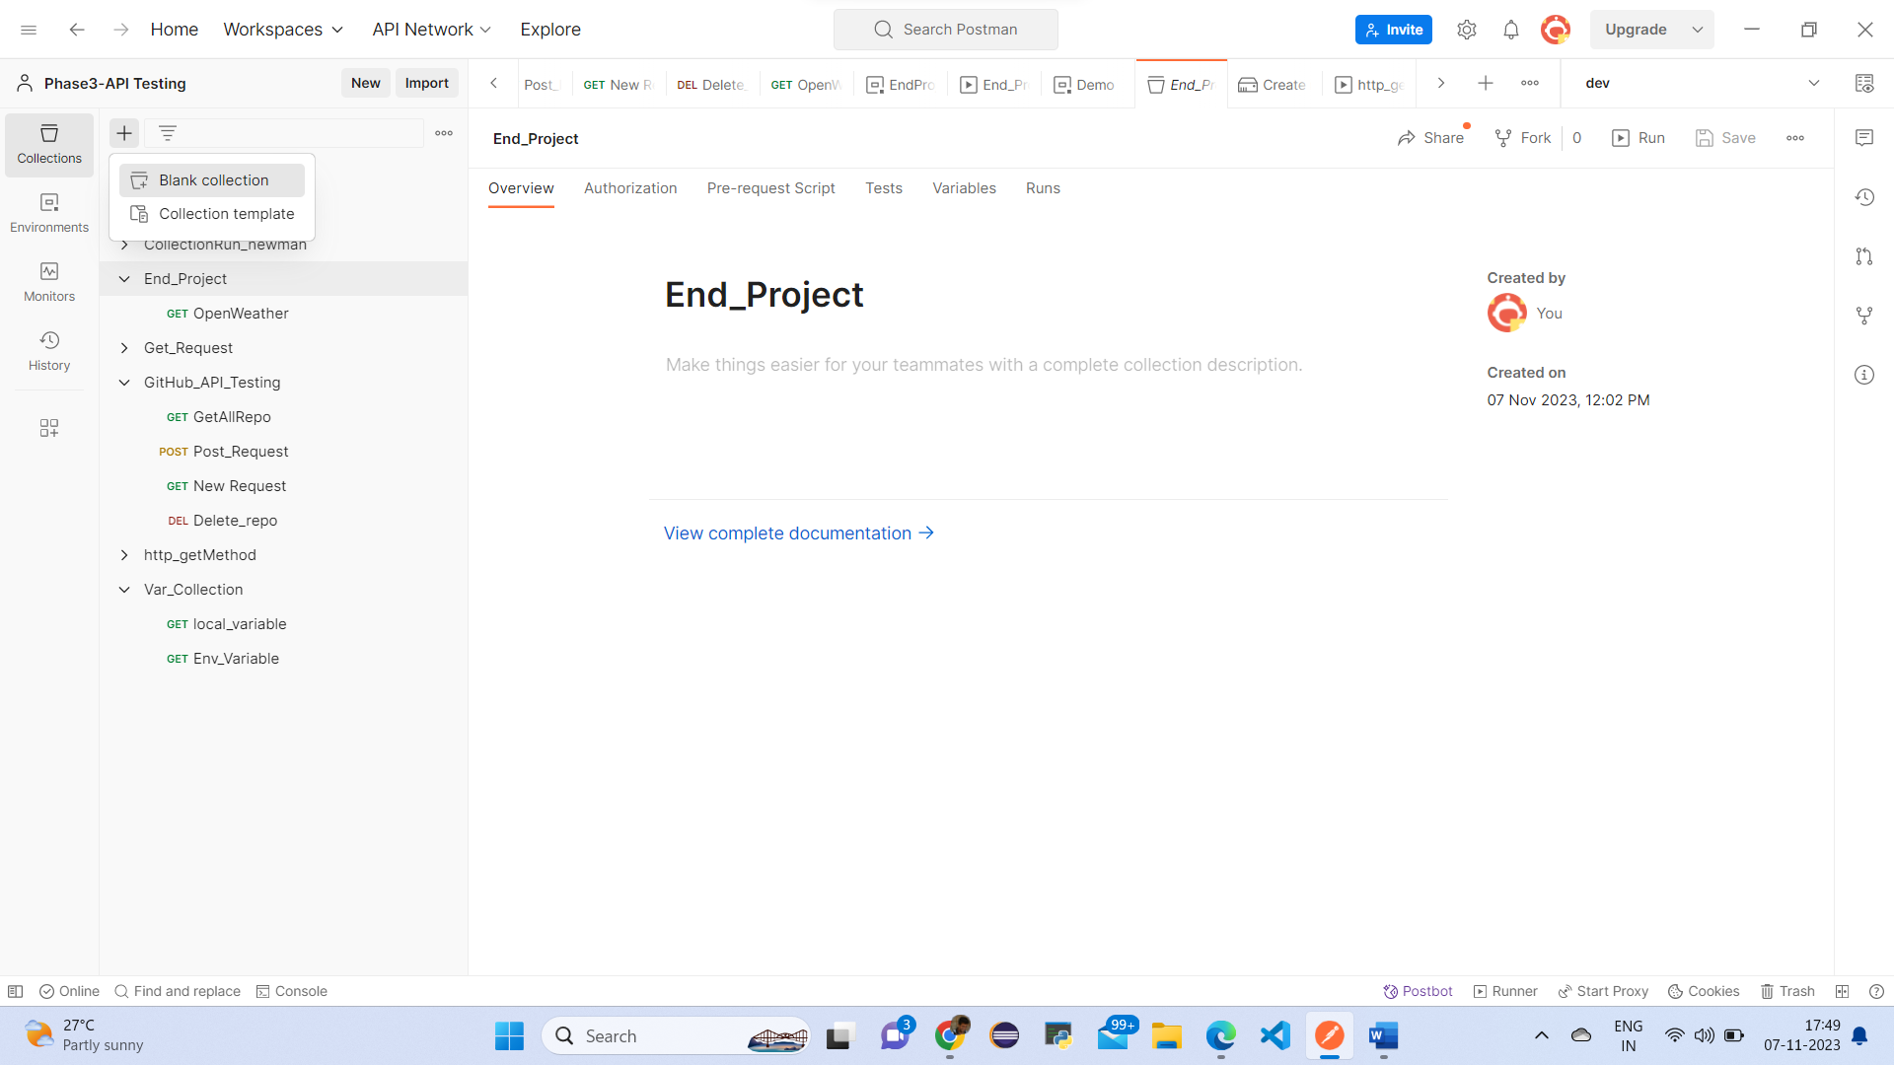

collection and put name as Lesson2- end project successfully lesson2-project are created.

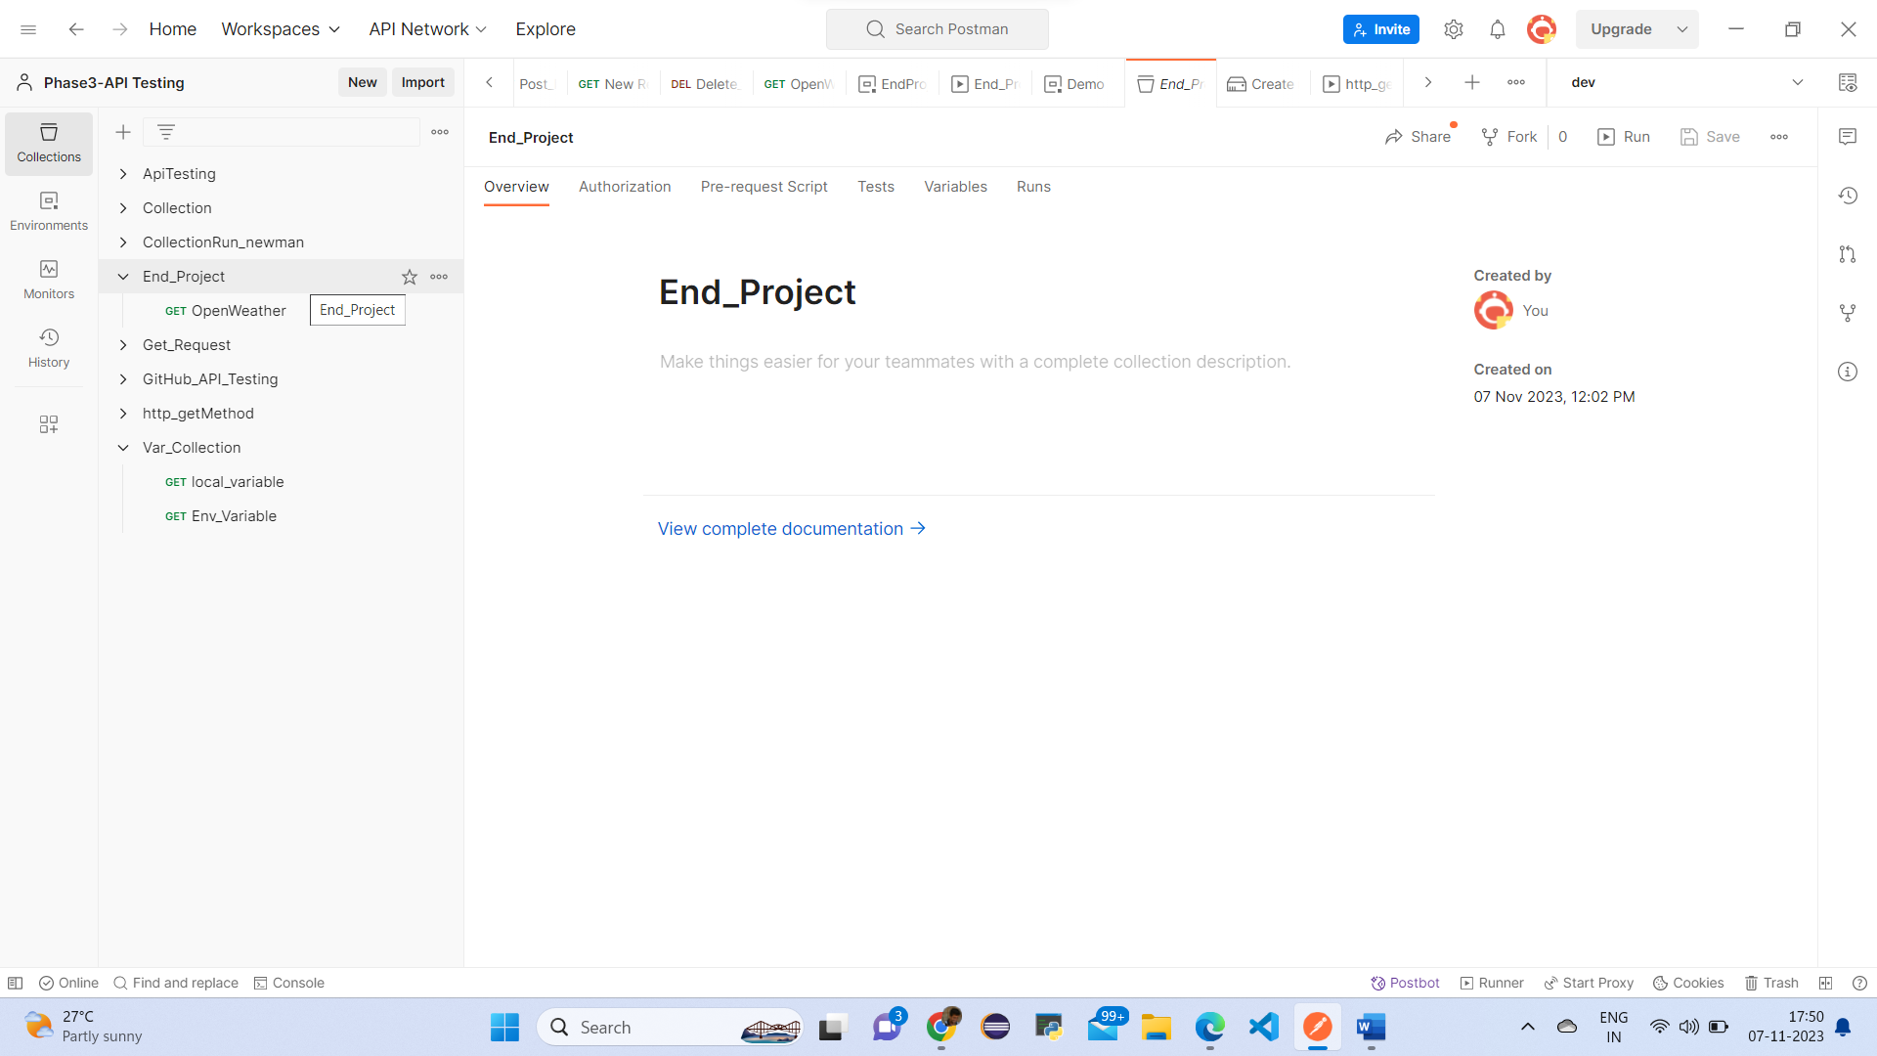

And lesson2-end project have 3 dots click on 3 dots have add request click on add request

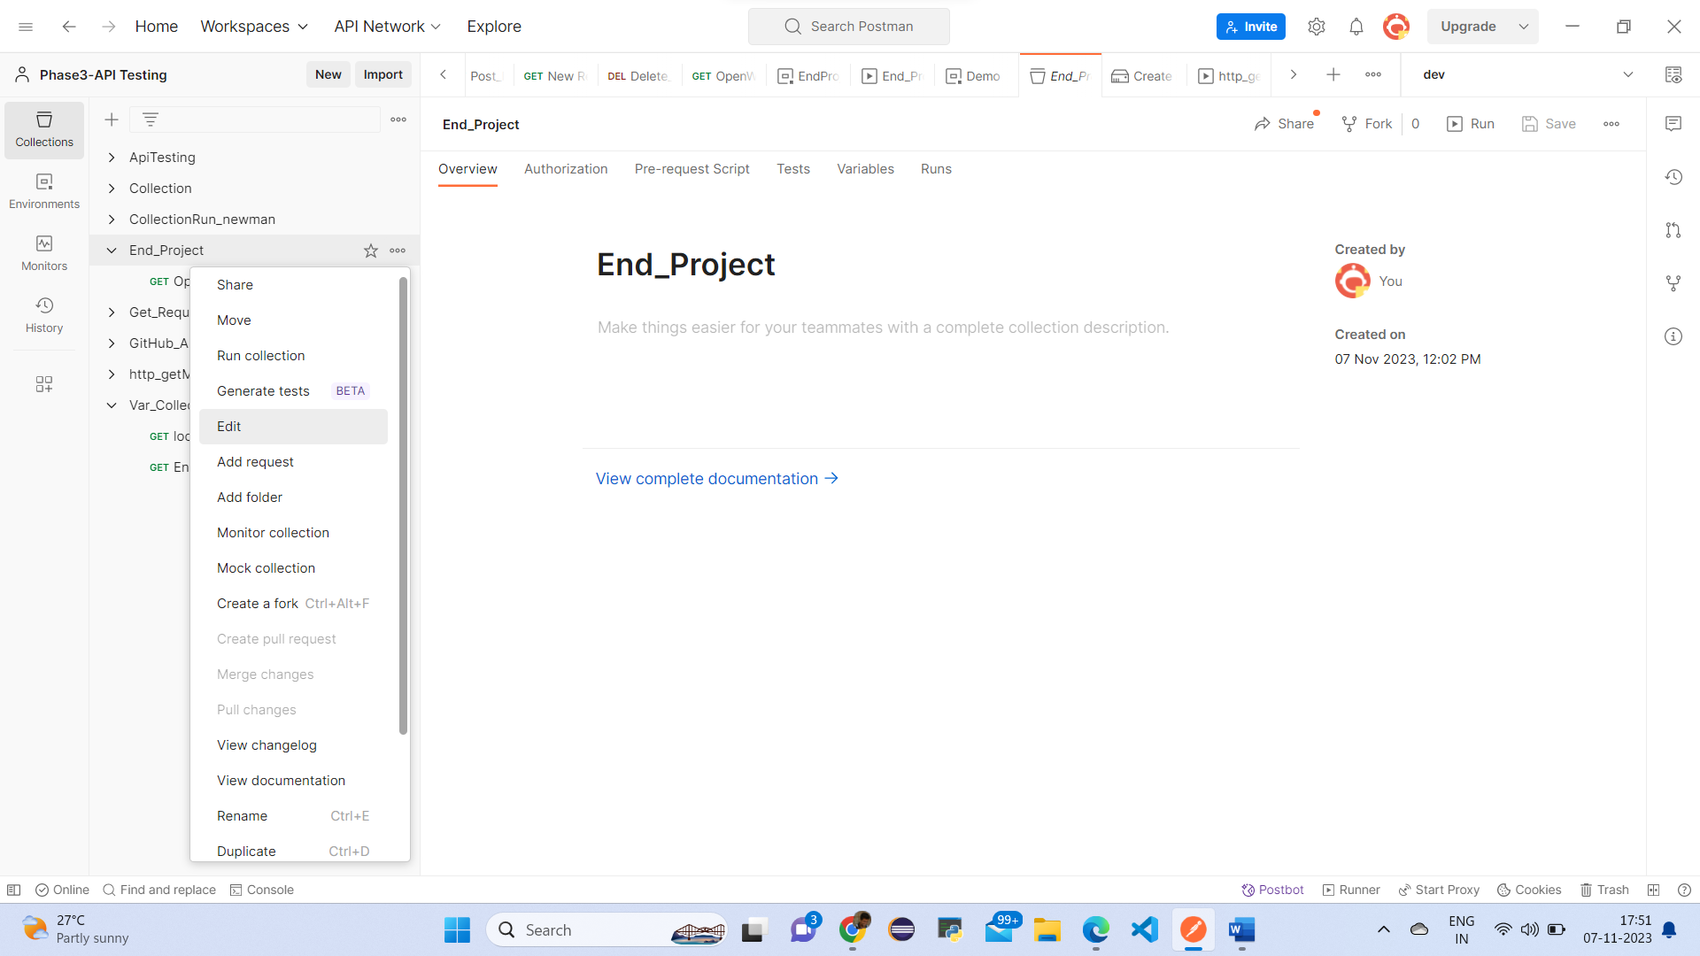

And put name as openweather req

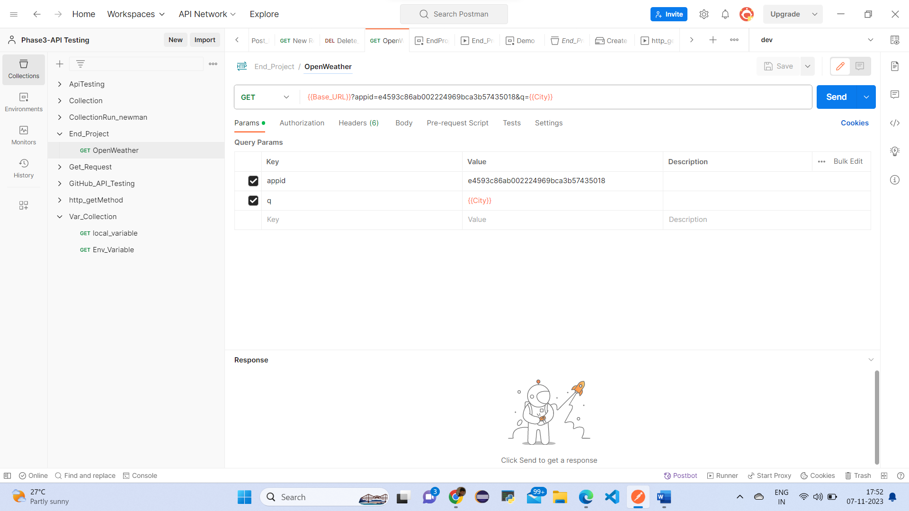

Add request name as openweatherreq in this below part select GET method & put URL

{{Base_URL}}?appid=e4593c86ab002224969bca3b57435018&q={{City}}

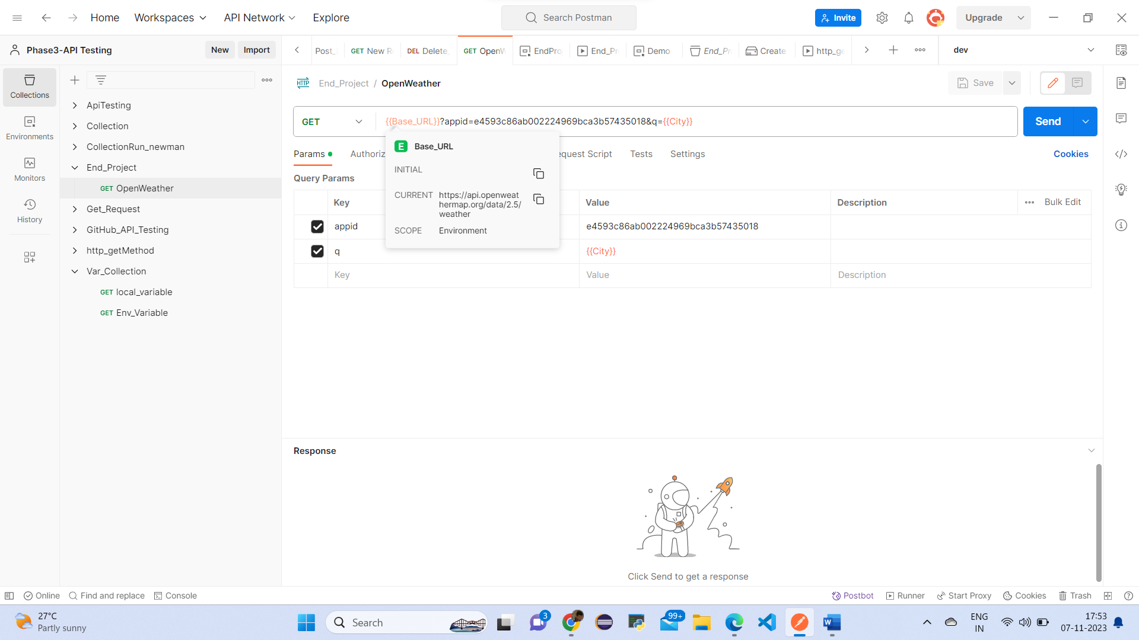

Take {{Base_URL}} is =https://api.openweathermap.org/data/2.5/weather

Take {{city}}=New York

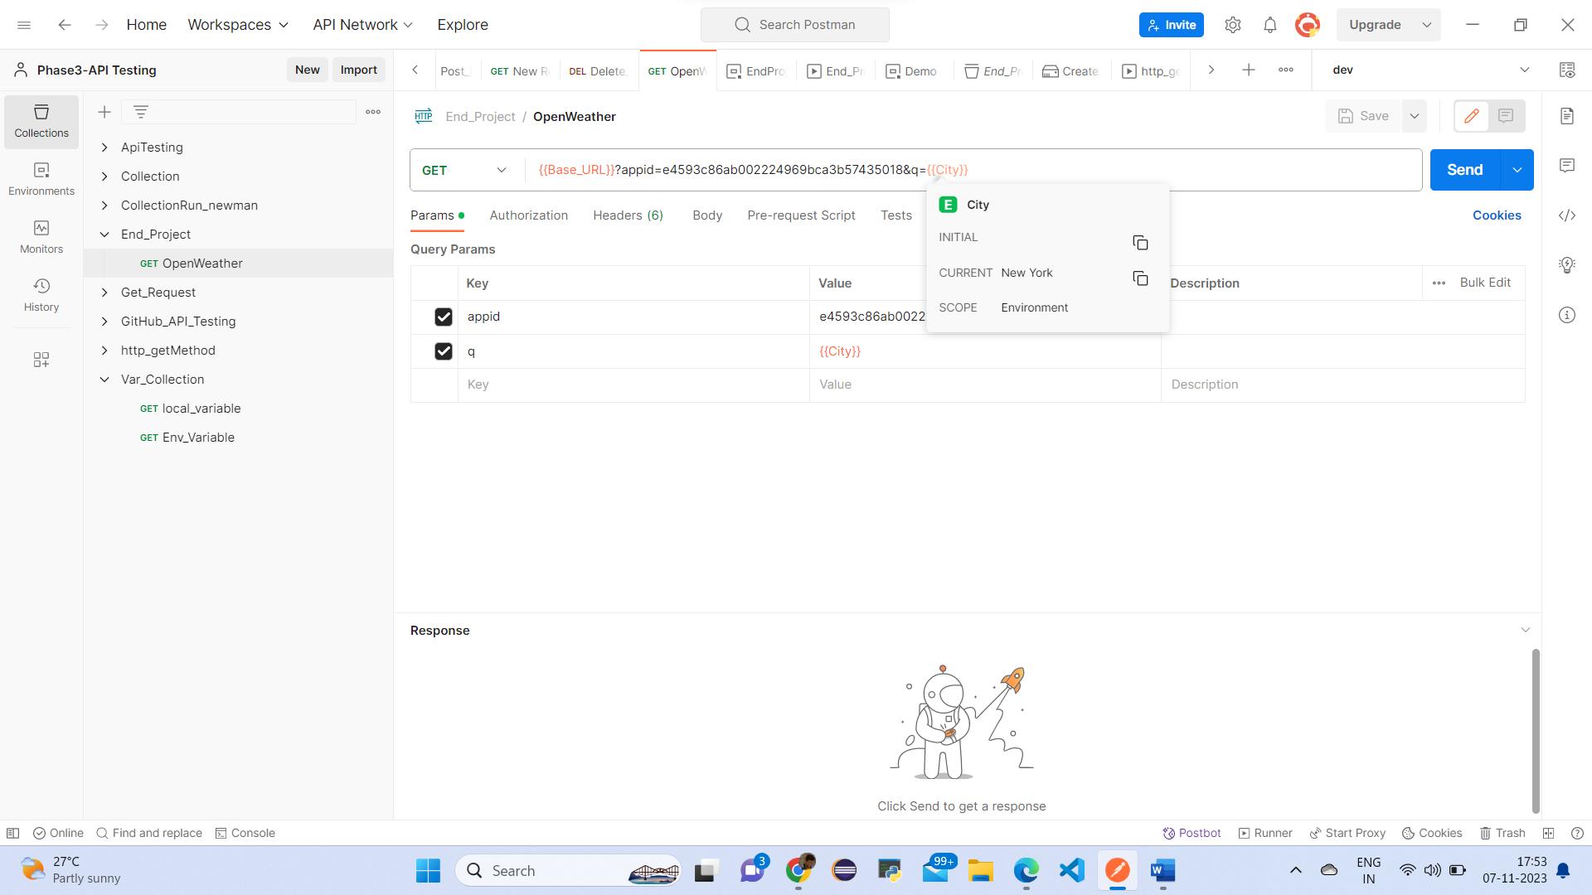

And create a environment variable for lesson2 – project put name as project - variables

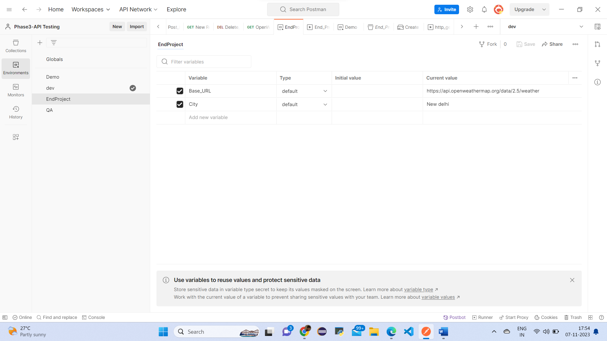

In this variables put name as Base_URL, city and select project – variables in collection area

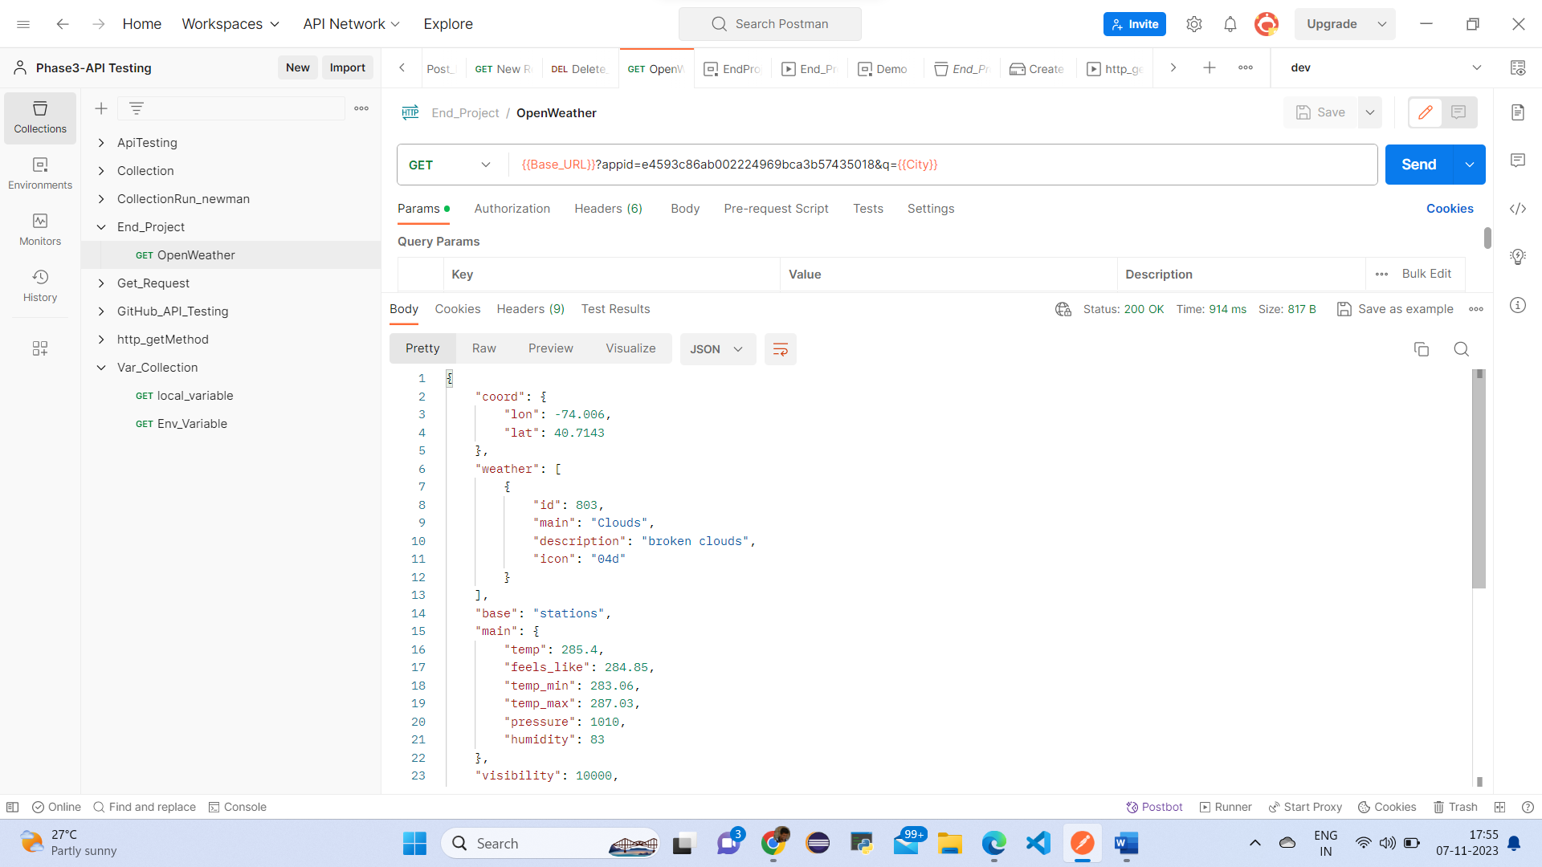

{

    "coord": {

        "lon": -74.006,

        "lat": 40.7143

    },

    "weather": [

        {

            "id": 803,

            "main": "Clouds",

            "description": "broken clouds",

            "icon": "04d"

        }

    ],

    "base": "stations",

    "main": {

        "temp": 285.4,

        "feels_like": 284.85,

        "temp_min": 283.06,

        "temp_max": 287.03,

        "pressure": 1010,

        "humidity": 83

    },

    "visibility": 10000,

    "wind": {

        "speed": 6.26,

        "deg": 360,

        "gust": 10.28

    },

    "clouds": {

        "all": 75

    },

    "dt": 1699359531,

    "sys": {

        "type": 2,

        "id": 2008101,

        "country": "US",

        "sunrise": 1699356785,

        "sunset": 1699393579

    },

    "timezone": -18000,

    "id": 5128581,

    "name": "New York",

    "cod": 200

}

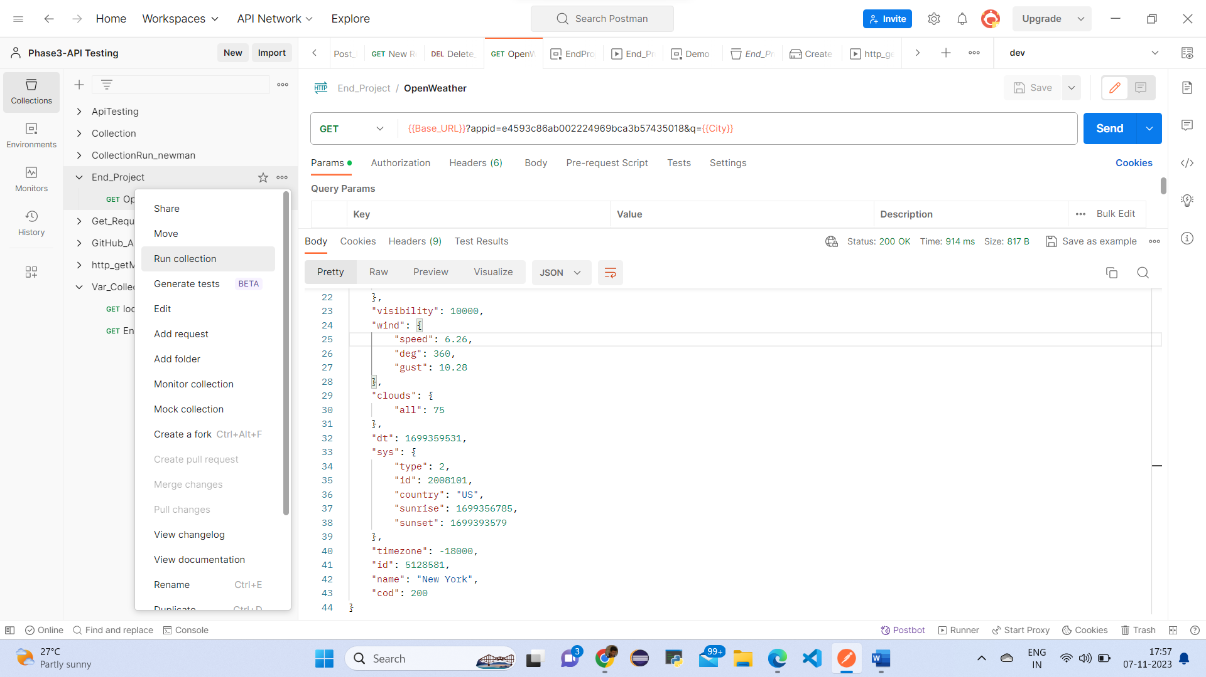

Click Lesson2-end project click on 3 dots have run collection

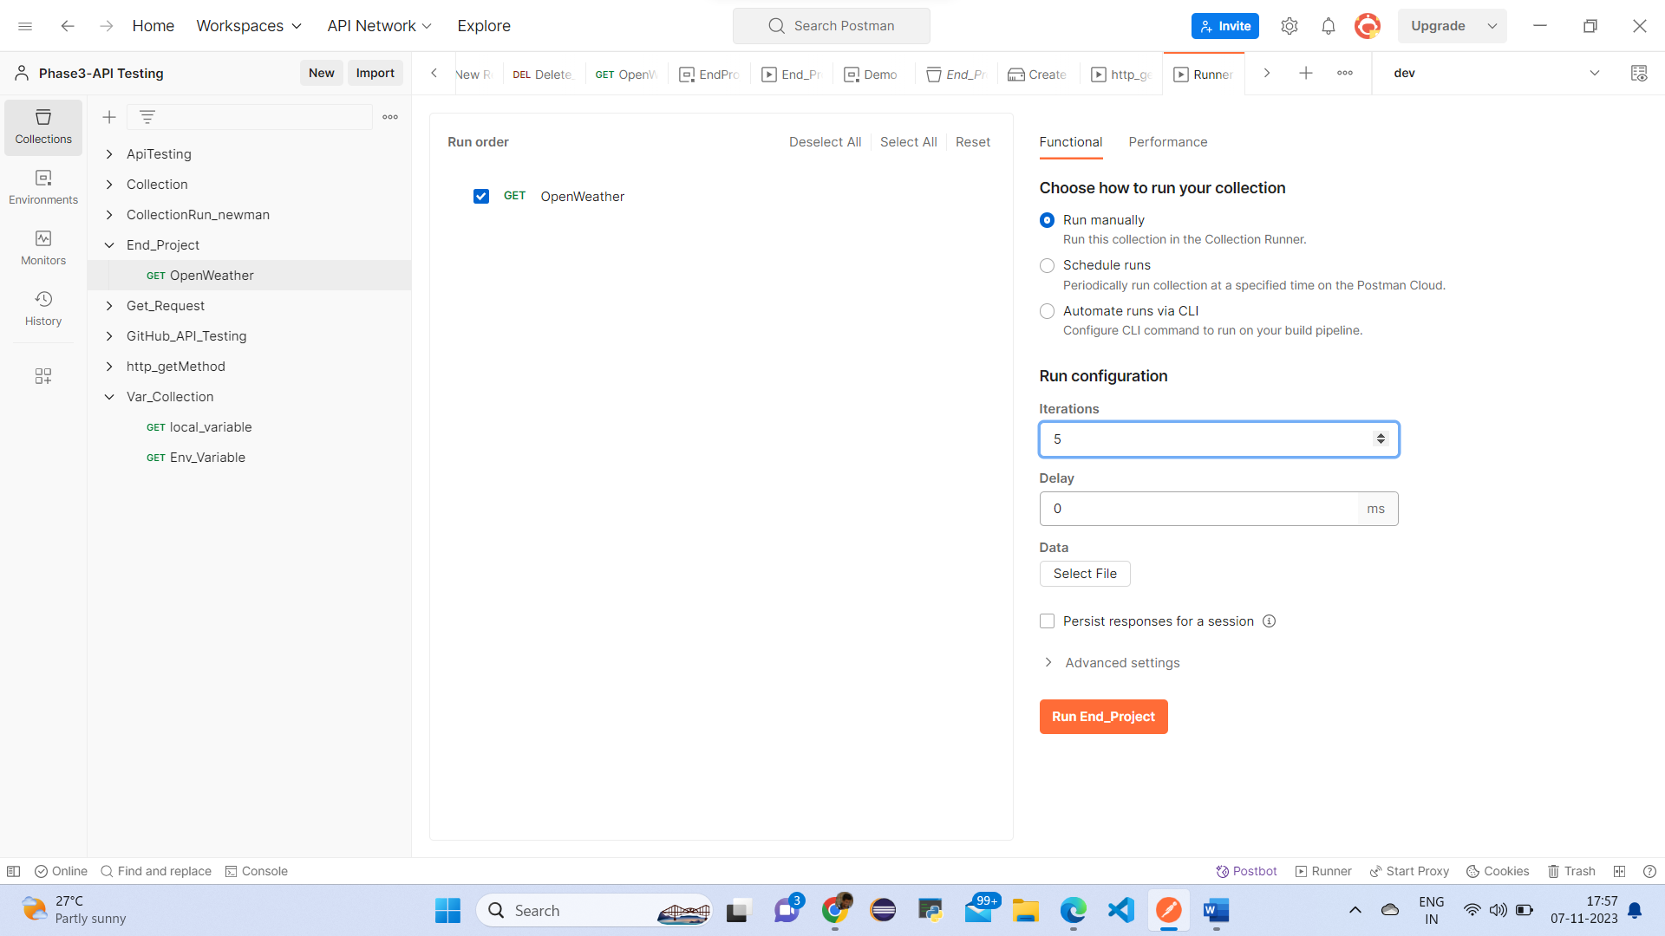

First create one excel and enter 5 cities names

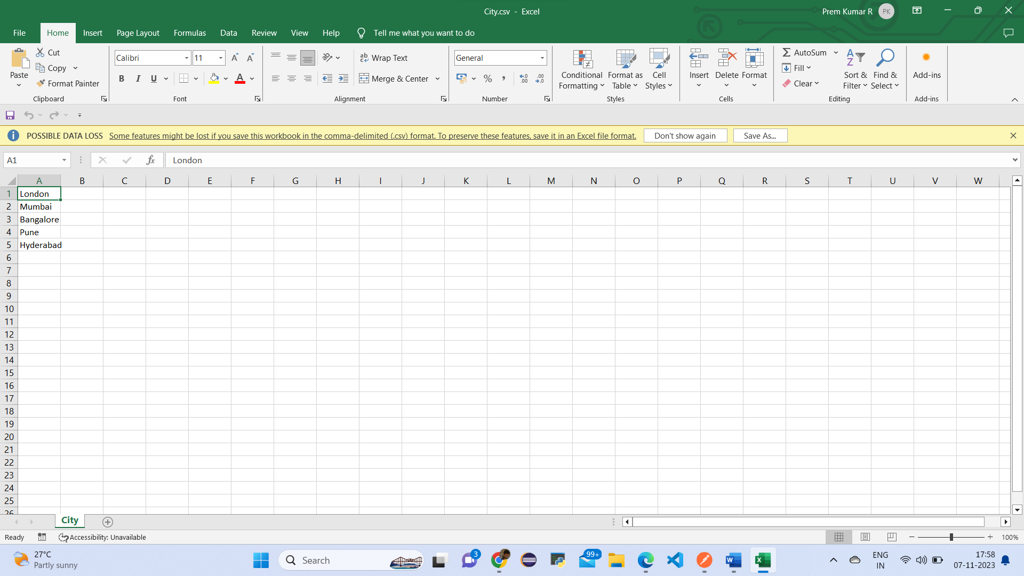

Save this file as cities & and save this excel in css & delimeter & save as in desktop folder

Run this results

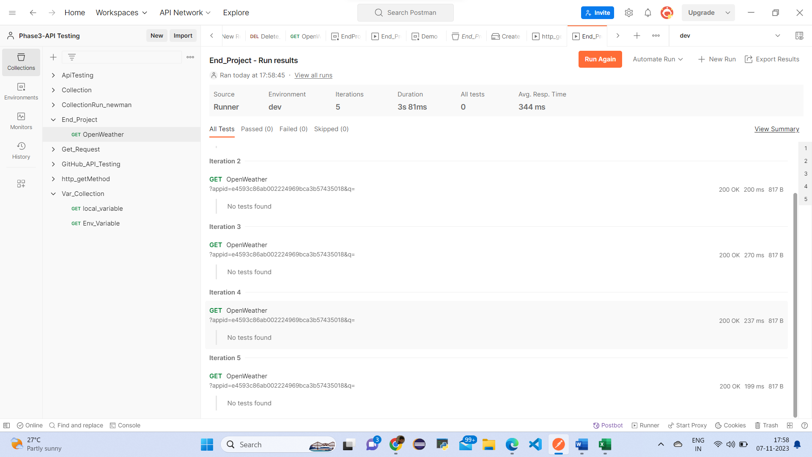

This above picture is summary report

Final output Result is

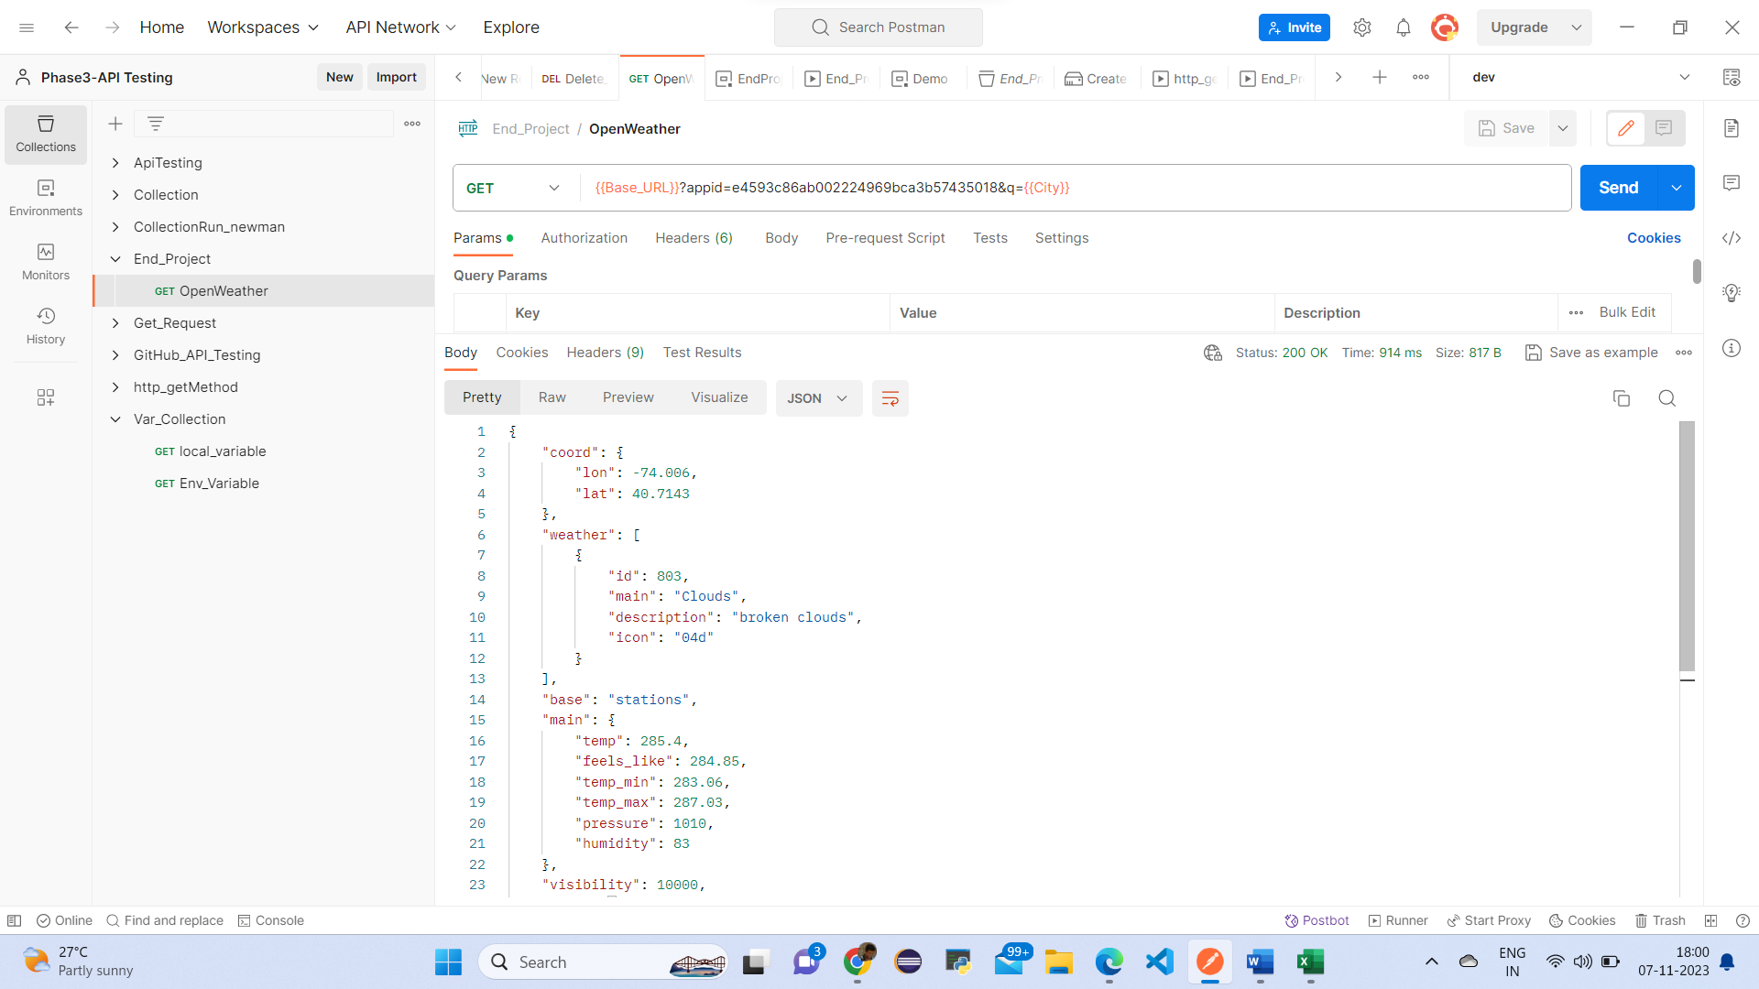

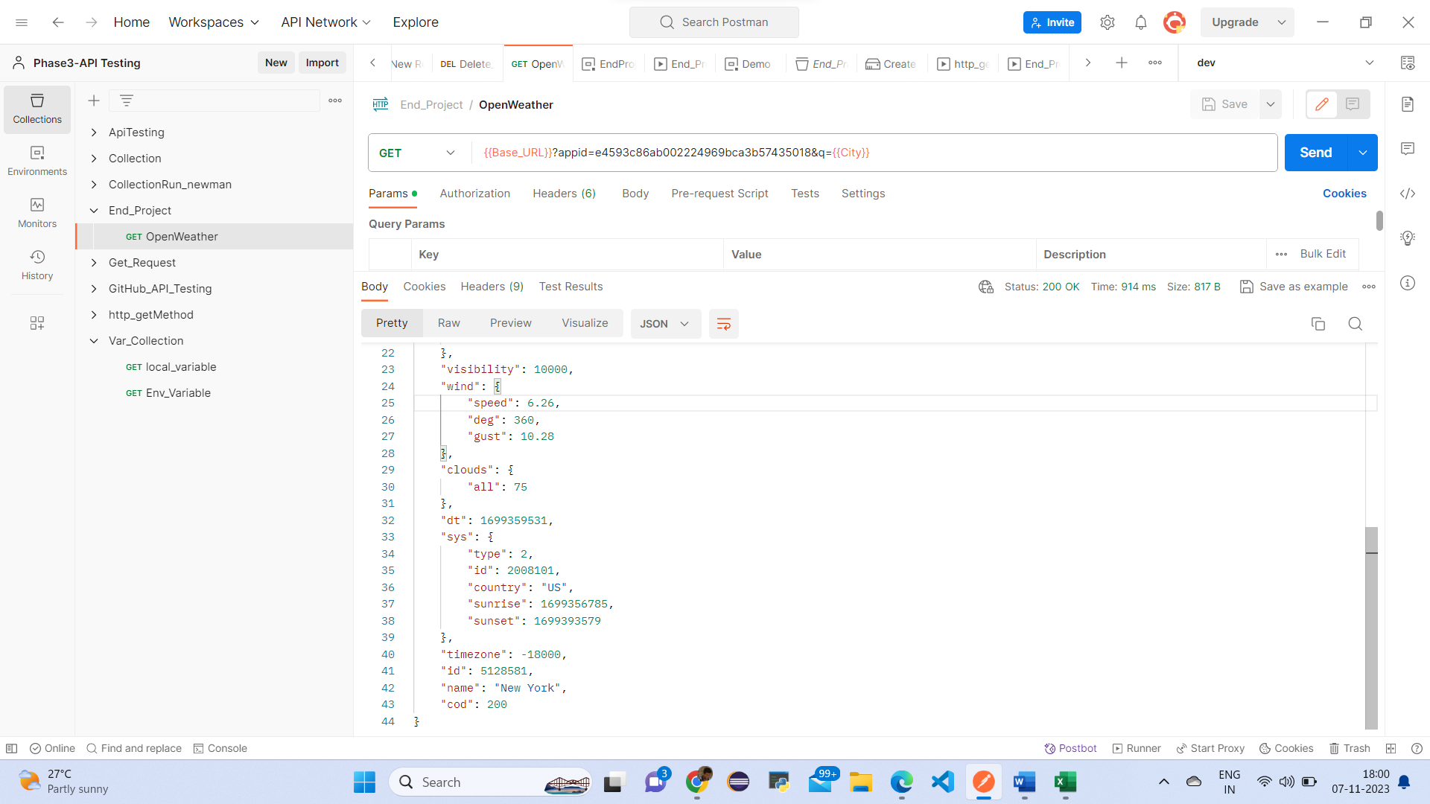

This is final result output.

**Screen Shots**

